**Complaint API Documentation**

**User Management:**

1. **Authentication** (/api/user/authenticate) **(Post Method)**

It accepts **JSON** format with given below model:

{

    "Username" : "rashidhussain",

    "Password" : "123"

}

**Postman Results:**

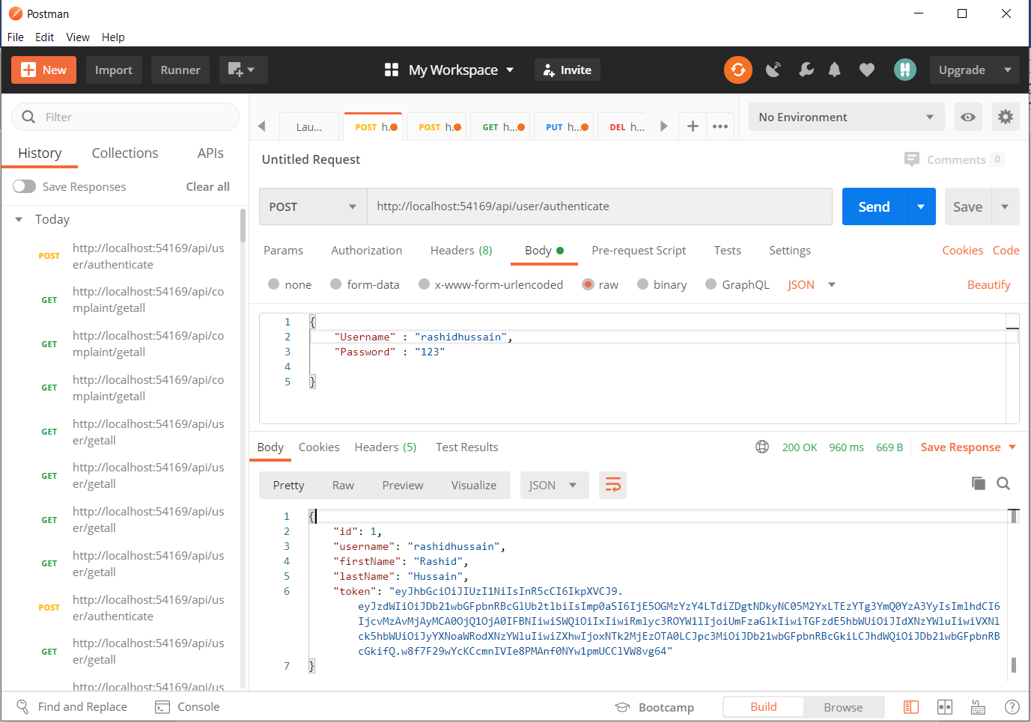

1. **Register** (/api/user/register) **(Post Method)**

It accepts **JSON** format with given below model:

{

    "FirstName" : "Asad",

    "LastName" : "Ali",

    "Username" : "asad",

    "Password" : "123"

}

**Postman Results:**

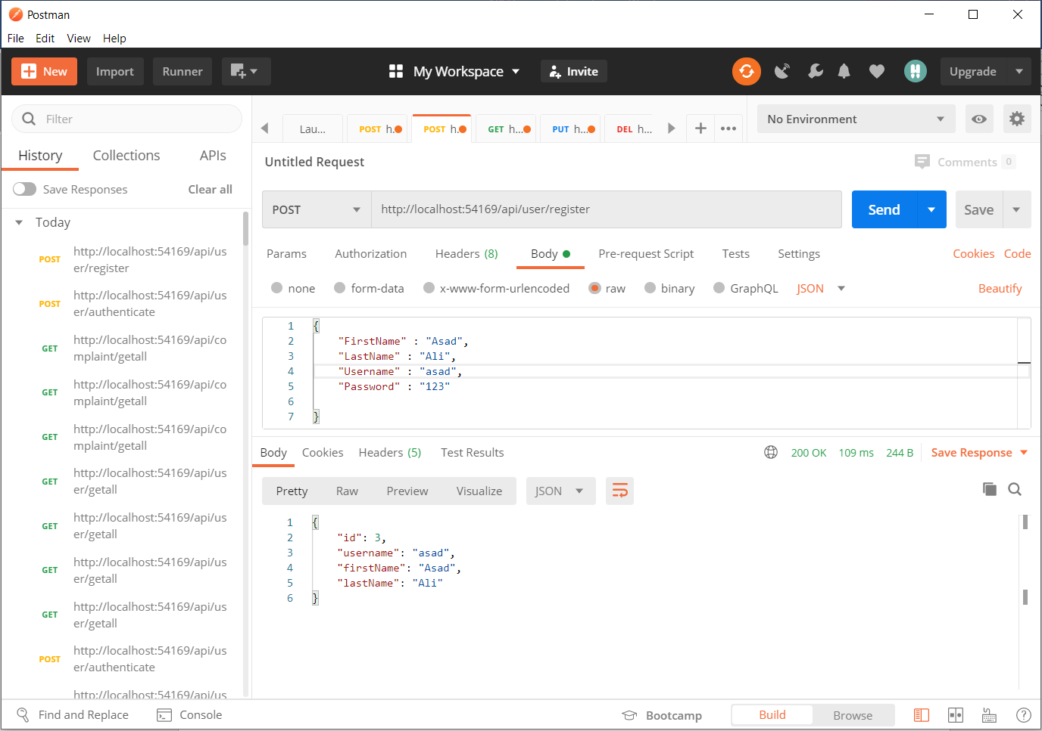

1. **Get All Users** (/api/user/getall) **(Get Method)**

It **does not accept anything** but a header with bearer token.

**Postman Results:**

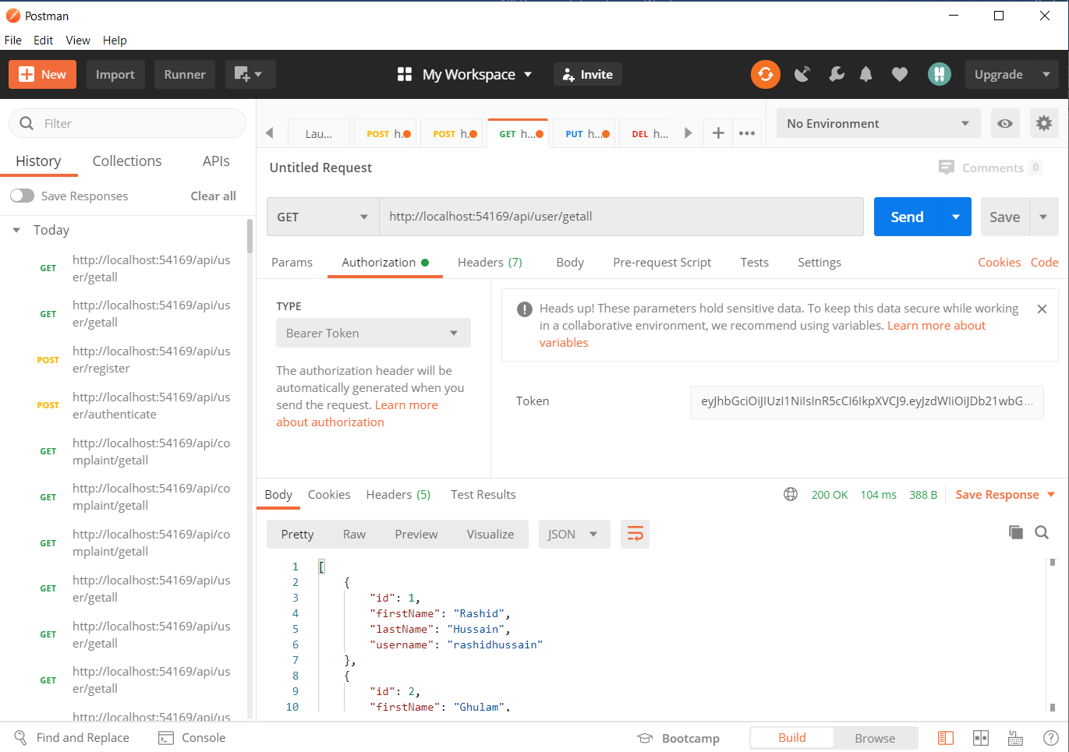

1. **Update** (/api/user/update) **(Put Method)**

It accepts **JSON** format and a bearer token with given below model:

{

    "Id":1,

    "FirstName" : "Asad",

    "LastName" : "Ali",

    "UserName" : "rk"

}

**Postman Results:**

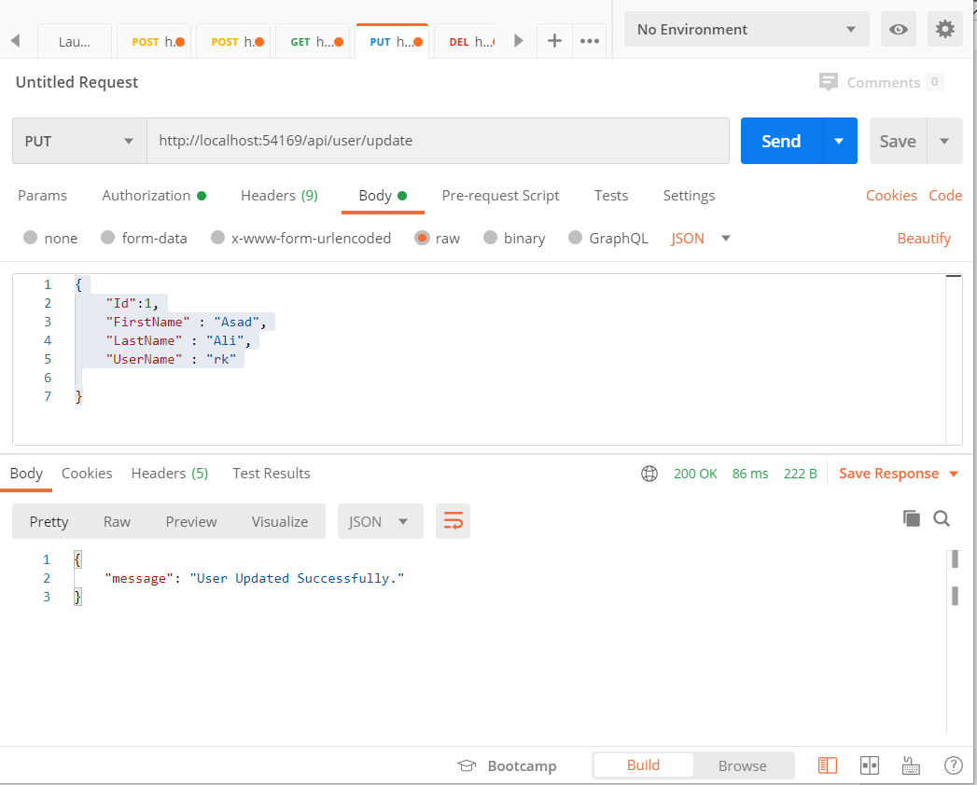

1. **Delete** (/api/user/delete) **(Delete Method)**

It accepts **id** in parameter with bearer token in header.

**Postman Results:**

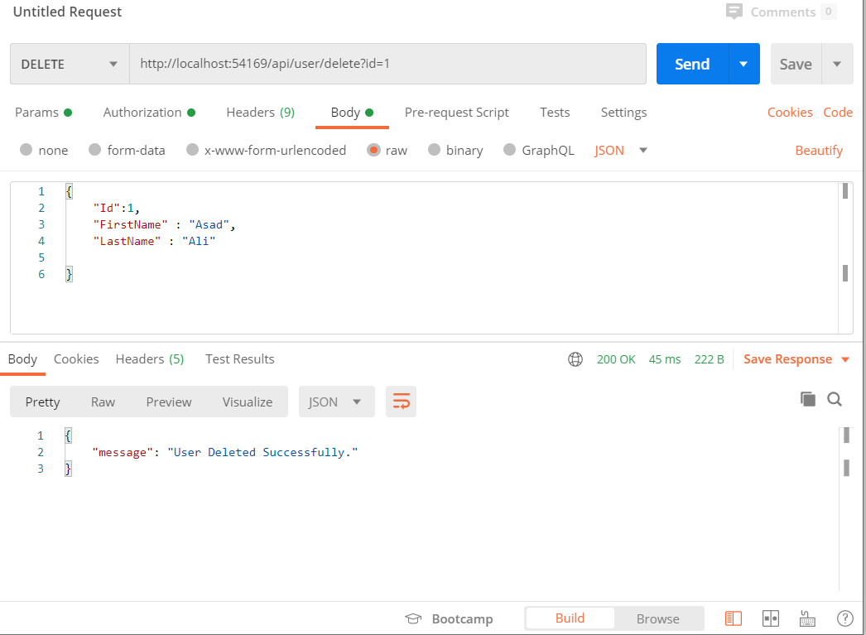

1. **Get by id** (/api/user/getbyid) **(Get Method)**

It accepts **id** in parameter with bearer token in header.

**Postman Results:**

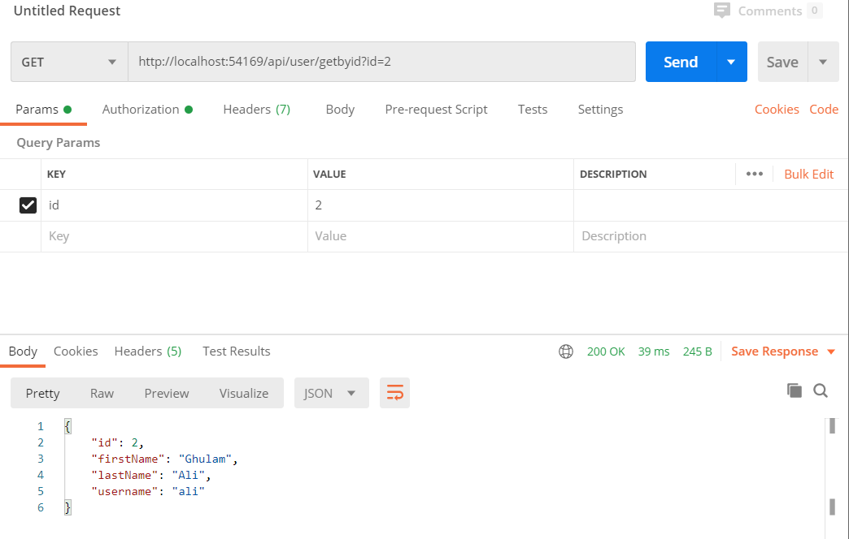

**Complaint Management:**

1. **Create Complaint** (/api/complaint/create) **(Post Method)**

It accepts **JSON** format with given below model:

  {

         "customerName": "Rashid Hussain new",

         "customerContact": "03145360520 new",

         "customerCity": "Rawalpindi new",

         "complaintType": "Internet Connectivity Issue new",

         "complaintDescription": "When user connects to the enter he gets limited connection. new",

         "status": "Completed",

         "DateOfComplaint" : "2020-07-31"

         }

**Postman Results:**

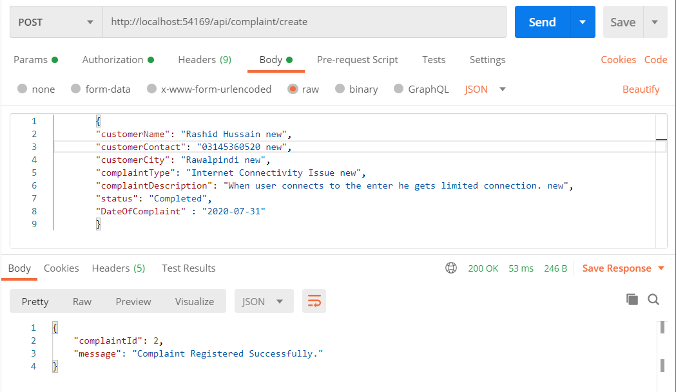

1. **Get All Complaints** (/api/complaint/getall) **(Get Method)**

It **does not accept anything** but a header with bearer token.

**Postman Results:**

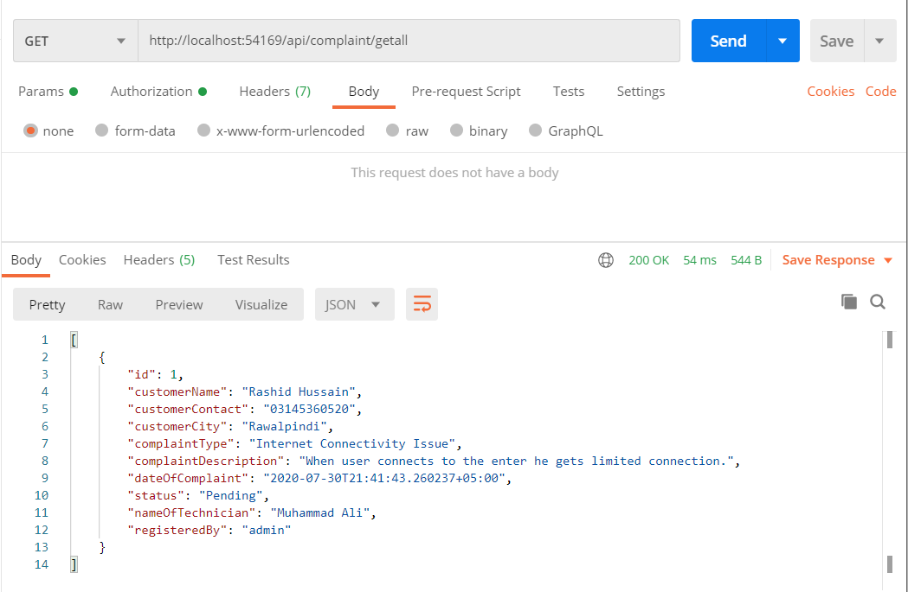

1. **Update** (/api/complaint/update) **(Put Method)**

It accepts **JSON** format and a bearer token with given below model:

{

        "id": 1,

        "customerName": "Rashid Hussain new",

        "customerContact": "03145360520 new",

        "customerCity": "Rawalpindi new",

        "complaintType": "Internet Connectivity Issue new",

        "complaintDescription": "User is unable to connect to internet.",

        "status": "Completed"

        }

**Postman Results:**

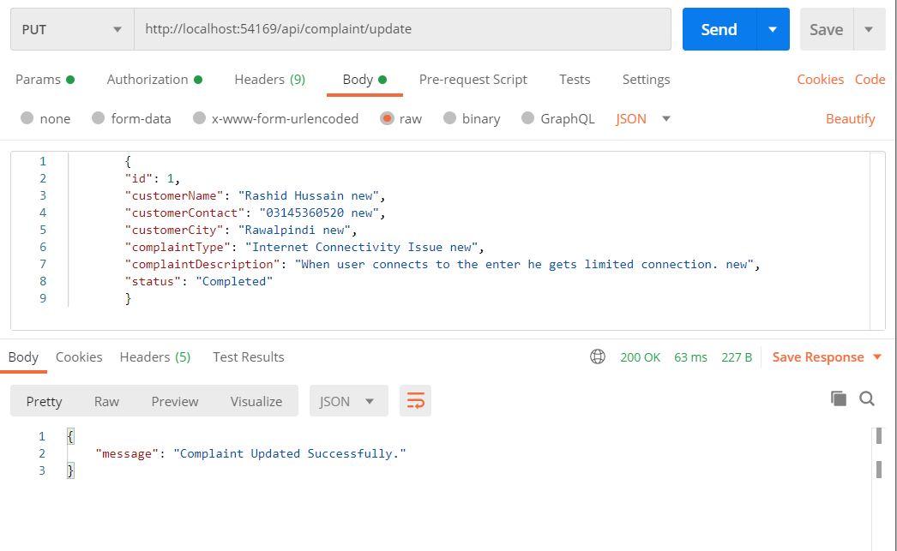

1. **Delete** (/api/complaint/delete) **(Delete Method)**

It accepts **id** in parameter with bearer token in header.

**Postman Results:**

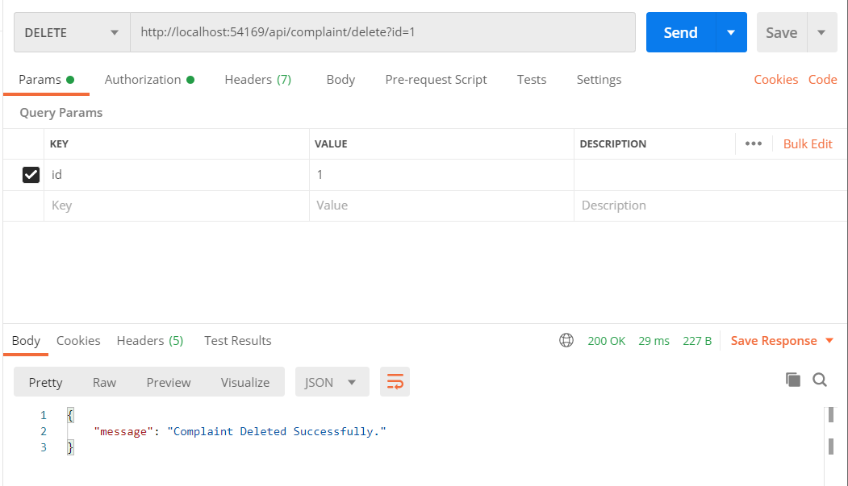

1. **Get by id** (/api/complaint/getbyid) **(Get Method)**

It accepts **id** in parameter with bearer token in header.

**Postman Results:**

